**Annasaheb Dange College of Engineering and Technology, Ashta**

Class: B. Tech Div: B

Sub: Deep Learning Date: 30-10-2023

**ISE – 2 (Activity 2): Case Study**

Created by,

|  |  |  |
| --- | --- | --- |
| Roll | Name | URN |
| 4115 | Suyesh Jayvant Patil | 20131087 |
| 4120 | Suraj Parasharam Patil | 20131086 |

Topic:

**Application of Computer Vision (i.e. Face Recognition System)**

A case study about face recognition along with usage, concerns, and current state in the world of this technology.

**Introduction**

Face recognition is a technology capable of identifying or verifying a subject through an image, video, or any audiovisual element of his face. Generally, this identification is used to access an application, system, or service. It is a method of biometric identification that uses that body measures, in this case, face and head, to verify the identity of a person through its facial biometric pattern and data. The technology collects a set of unique biometric data of each person associated with their face and facial expression to identify, verify and/or authenticate a person. The procedure simply requires any device that has digital photographic technology to generate and obtain the images and data necessary to create and record the biometric facial pattern of the person that needs to be identified.

Unlike other identification solutions such as passwords, verification by email, selfies or images, or fingerprint identification, Biometric facial recognition uses unique mathematical and dynamic patterns that make this system one of the safest and most effective ones.



Face recognition

**How face recognition works?**

You might be good at recognizing faces. You probably find it a cinch to identify the face of a family member, friend, or acquaintance. You’re familiar with their facial features — their eyes, nose, mouth — and how they come together.

That’s how a facial recognition system works, but on a grand, algorithmic scale. Where you see a face, recognition technology sees data. That data can be stored and accessed.

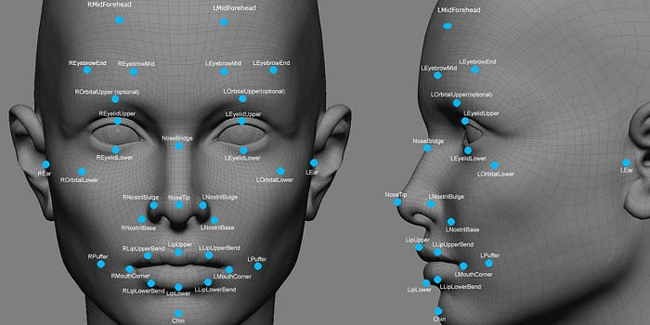

So how does facial recognition work? Technologies vary, but here are the basic steps:

Step 1. A picture of your face is captured from a photo or video. Your face might appear alone or in a crowd. Your image may show you looking straight ahead or nearly in profile.

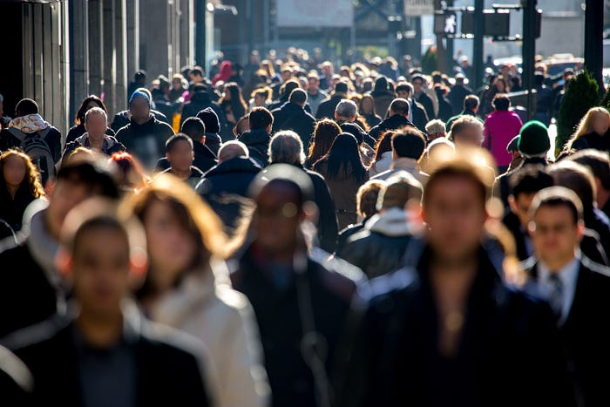

Step 2. Facial recognition software reads the geometry of your face. Key factors include the distance between your eyes and the distance from forehead to chin. The software identifies facial landmarks — one system identifies 68 of them — that are key to distinguishing your face. The result: your facial signature.

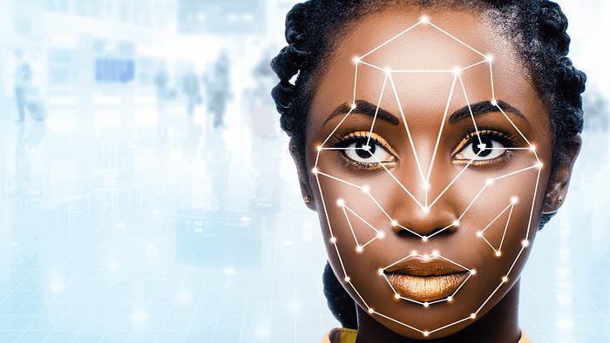

Step 3. Your facial signature — a mathematical formula — is compared to a database of known faces. And consider this: at least million people have images of their faces in one or more databases.

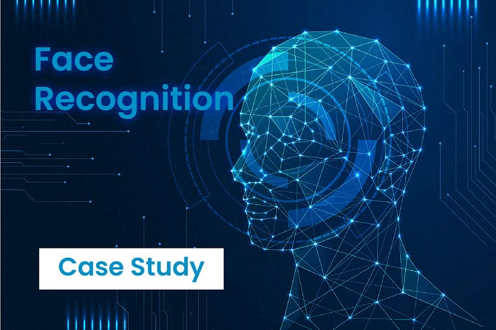

Step 4. A determination is made. Your faceprint may match that of an image in a facial recognition system database.

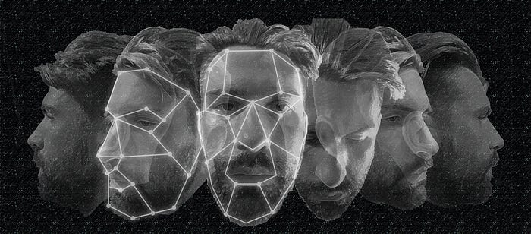

**Who uses facial recognition?**

* Mobile phone makers in products. Apple first used facial recognition to unlock its iPhone X, and continues with the iPhone XS. Face ID authenticates — it makes sure you’re you when you access your phone. Apple says the chance of a random face unlocking your phone is about one in 1 million.
* Social media companies on websites. Facebook uses an algorithm to spot faces when you upload a photo to its platform. The social media company asks if you want to tag people in your photos. If you say yes, it creates a link to their profiles. Facebook can recognize faces with 98 percent accuracy.
* Businesses at entrances and restricted areas. Some companies have traded in security badges for facial recognition systems. Beyond security, it could be one way to get some face time with the boss.
* Marketers and advertisers in campaigns. Marketers often consider things like gender, age, and ethnicity when targeting groups for a product or idea. Facial recognition can be used to define those audiences even at something like a concert.

**Challenges Faced by Facial Recognition System**

**Illumination**

Illumination stands for light variations. The slight change in lighting conditions cause a significant challenge for automated face recognition and can have a significant impact on its results. If the illumination tends to vary, the same individual gets captured with the same sensor and with an almost identical facial expression and pose, the results that emerge may appear quite different.

Illumination changes the face appearance drastically. It has been found that the difference between two same faces with different illuminations is higher than two different faces taken under same illumination.

**Pose**

Facial Recognition Systems are highly sensitive to pose variations. The pose of a face varies when the head movement and viewing angle of the person changes. The movements of head or differing POV of a camera can invariably cause changes in face appearance and generate intra‐class variations making automated face recognition rates drop drastically. It becomes a challenge to identify the real face when the rotation angle goes higher. It may result in faulty recognition or no recognition if the database only has the frontal view of the face.

**Occlusion**

Occlusion means blockage, and it occurs when one or other parts of the face are blocked and whole face is not available as an input image. Occlusion is considered one of the most critical challenges in face recognition system.

It occurs due to beard, moustache, accessories (goggle, cap, mask, etc.), and it is prevalent in real-world scenario. The presence of such components makes the subject diverse and hence making automated face recognition process a tough nut to crack.

**Expressions**

Face is one of the most crucial biometrics as its unique features play a crucial role in providing human identity and emotions. Varying situations cause different moods which result in showing various emotions and eventually change in facial expressions.

Different expressions of the same individual are another significant factor that needs to be taken into account. Human expressions are particularly macro-expressions which are happiness, sadness, anger, disgust, fear, surprise. Micro-expressions are the one which shows the rapid facial patterns and happen involuntarily.

Macro and micro expressions find their place on someone’s face due to changes in one’s emotional state and in the wake of such emotions- which are many- the efficient recognition becomes difficult.

**State of Facial Recognition across the world**

North America, Central America, and Caribbean

More recently, the Department of Homeland Security unveiled its [“Biometric Exit”](https://thehill.com/policy/technology/439481-dhs-wants-to-use-facial-recognition-on-97-percent-of-departing-air) plan, which aims to use facial recognition technology on nearly all air travel passengers by 2023, to identify compliance with visa status.

Perhaps surprisingly, 59% of Americans are actually in favour of [implementing facial recognition technology](https://www.analyticsinsight.net/facial-recognition-in-retail-banking-and-ip-surveillance/), considering it acceptable for use in law enforcement according to a [Pew Research](https://www.statista.com/chart/19321/facial-recognition-public-opinion/) survey. Yet, some cities such as San Francisco have pushed to ban surveillance, citing a stand against its potential abuse by the government.[Facial recognition technology](https://www.analyticsinsight.net/best-facial-recognition-software/) can potentially come in handy after a natural disaster. After Hurricane Dorian hit in late summer of 2019, the Bahamas launched a blockchain-based missing persons database “FindMeBahamas” to identify thousands of displaced people.

**Europe**

Belgium and Luxembourg are two of only three governments in the world to officially oppose the use of facial recognition technology.

*“*The EU has been a haven for unlawful biometric experimentation and surveillance.”

— European Digital Rights (EDRi)

In Russia, authorities have relied on facial recognition technology to check for breaches of [quarantine](https://abcnews.go.com/International/russia-facial-recognition-police-coronavirus-lockdown/story?id=70299736) rules by potential COVID-19 carriers. In Moscow alone, there are reportedly over 100,000 facial recognition enabled cameras in operation.

**East Asia and Oceania**

In the COVID-19 battle, contact tracing through biometric identification became a [common tool](https://hbr.org/2020/04/how-digital-contact-tracing-slowed-covid-19-in-east-asia) to slow the infection rates in countries such as China, South Korea, Taiwan, and Singapore. In some instances, this included the use of facial recognition technology to monitor temperatures as well as spot those without a mask.

China is often cited as a notorious use case of mass surveillance, and the country has the [highest ratio](https://multimedia.scmp.com/infographics/news/world/article/3034080/most-surveilled-cities/index.html) of CCTV cameras to citizens in the world — one for every 12 people.

By 2023, China will be the single biggest player in the global facial recognition market. And it’s not just implementing the technology at home–it’s exporting too!!

**Africa**

While the African continent currently has the lowest concentration of facial recognition technology in use, this deficit may not last for long.

Several African countries, such as Kenya and Uganda, have received telecommunications and surveillance [financing](https://www.visualcapitalist.com/global-chinese-financing-is-fueling-megaprojects/) and infrastructure from Chinese companies — Huawei in particular. While the company claims this has enabled [regional crime rates to plummet](https://www.analyticsinsight.net/facial-recognition-threatening-privacy-detecting-crimes/), some activists are wary of the partnership.

**Middle East and Central Asia**

Facial recognition technology is widespread in this region, notably for military purposes.

In Turkey, 30 domestically-developed Kamikaze drones will use AI and facial recognition for border security. Similarly, Israel has a [close eye](https://www.npr.org/2019/08/22/752765606/face-recognition-lets-palestinians-cross-israeli-checkposts-fast-but-raises-conc) on Palestinian citizens across 27 West Bank checkpoints.

In other parts of the region, police in the UAE have purchased discreet smart glasses that can be used to scan crowds, where positive matches show up on an embedded lens display. Over in Kazakhstan, facial recognition technology could [replace public transportation passes entirely](https://www.analyticsinsight.net/the-ethical-viewpoint-of-facial-recognition-technology/).

**South America**

The majority of facial recognition technology in South America is aimed at cracking down on crime. In fact, it worked in Brazil to capture Interpol’s [second-most wanted](https://www.theguardian.com/technology/2019/oct/05/facial-recognition-technology-hurtling-towards-surveillance-state)criminal.

**Conclusion**

Face is the most essential part of the human body, and its unique features make it even more crucial in identifying humans. Various algorithms and technologies are used worldwide to make the face recognition process more accurate and reliable. The applications of this ever-growing technology are also expanding in healthcare, security, defence, forensic, and transportation, requiring more accuracy. However, some challenges are ubiquitous while developing face recognition technology such as pose, occlusion, expressions, ageing, etc, which have been discussed above in the art.